GUMUDAVELLI THRUSHITHA
2303A54058
BATCH-47_B
ASSIGNMENT -3

LAB EXPERIMENT 3: Prompt Engineering – Improving Prompts and Context Management

TASK 1 : Zero-Shot Prompting (Palindrome Number Program)

PROMPT : Write a Python function named is palindrome that takes an integer as input and returns True if the number is a palindrome and False otherwise. The function should correctly handle negative numbers and edge cases. Provide only the function code, without examples or explanations

LOGIC :Take a number, reverse it digit by digit, and compare it with the original number.
If both are equal (and the number is not negative), it is a palindrome; otherwise, it is not.

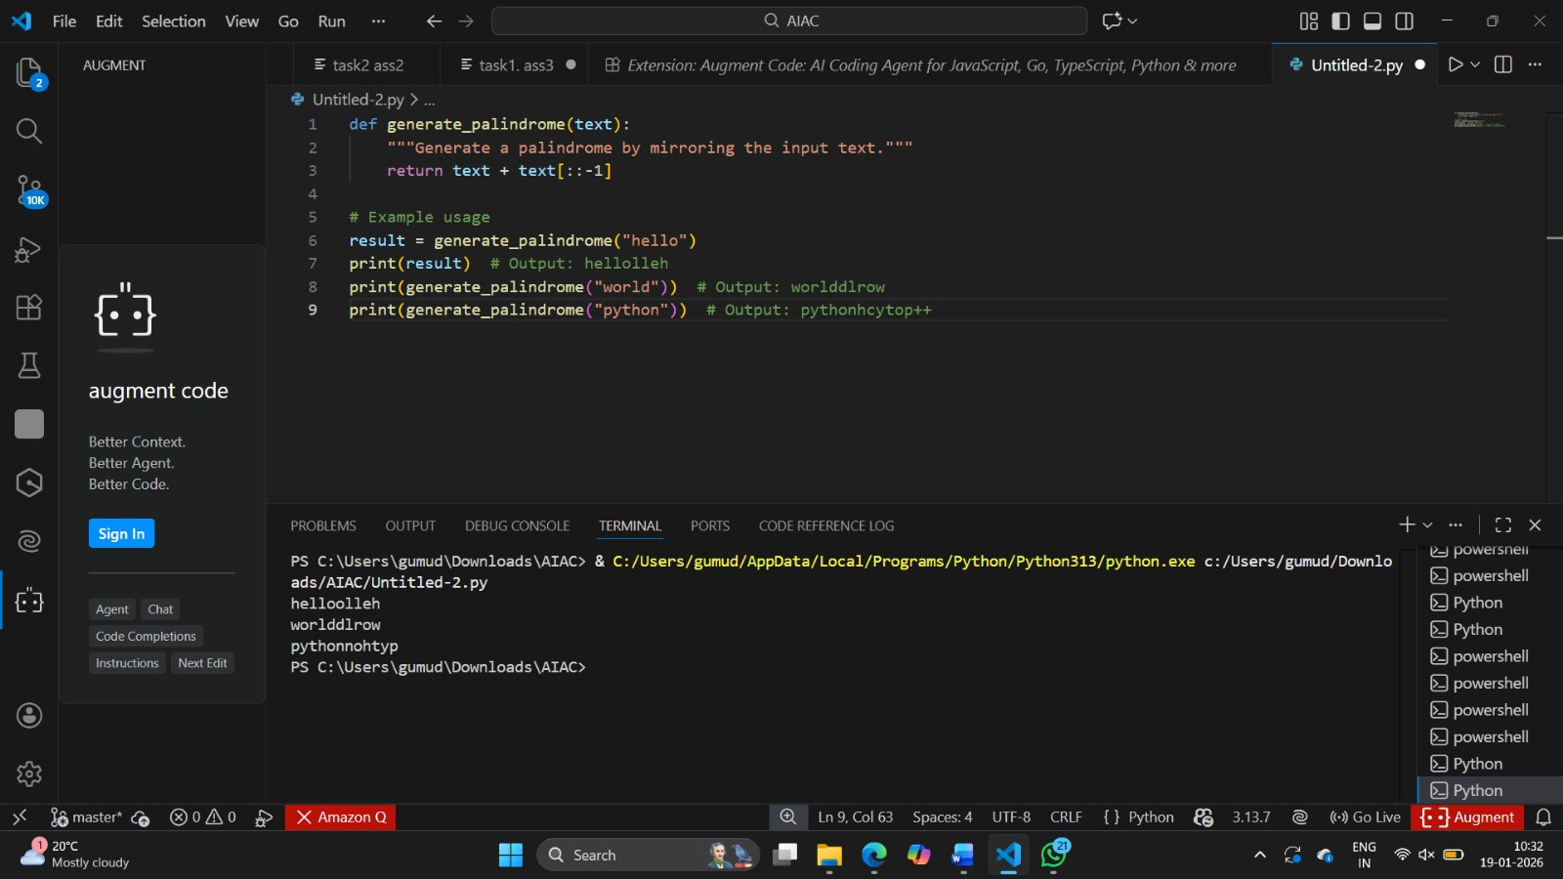

TASK 2: One-Shot Prompting (Factorial Calculation)

PROMPT: Write a Python function named factorial(n) that returns the factorial of a given non-negative integer.

LOGIC: Multiply all integers from 1 to the given number to compute the factorial.
If the number is 0 or 1, return 1 as the factorial value
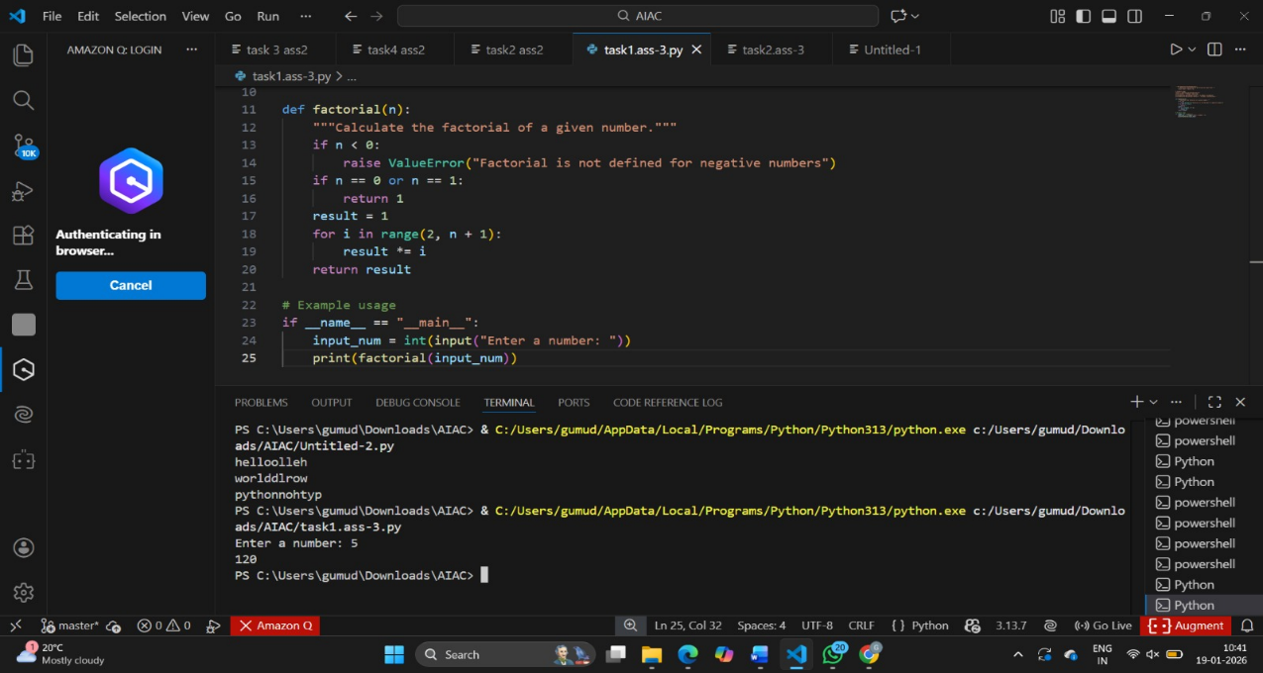

TASK3: Few-Shot Prompting (Armstrong Number Check)

PROMPT:Write a Python function named is Armstrong (n) that checks whether a given number is an Armstrong number.

LOGIC: Count the number of digits in the number and compute the sum of each digit raised to that power. If the sum equals the original number, it is an Armstrong number; otherwise, it is not.
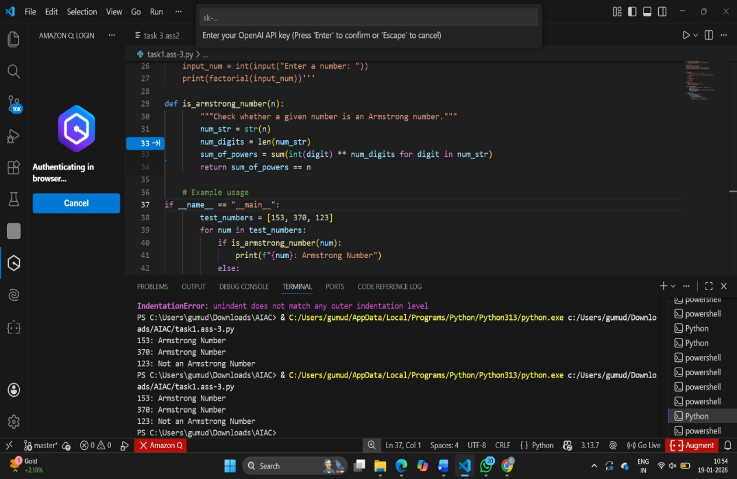

TASK 4: Context-Managed Prompting (Optimized Number Classification)

PROMPT: Write an efficient Python function to classify a number as Prime, Composite, or Neither with proper input validation.

LOGIC: If n ≤ 1 → Neither; else check factors only up to √n.
No factors → Prime, otherwise → Composite

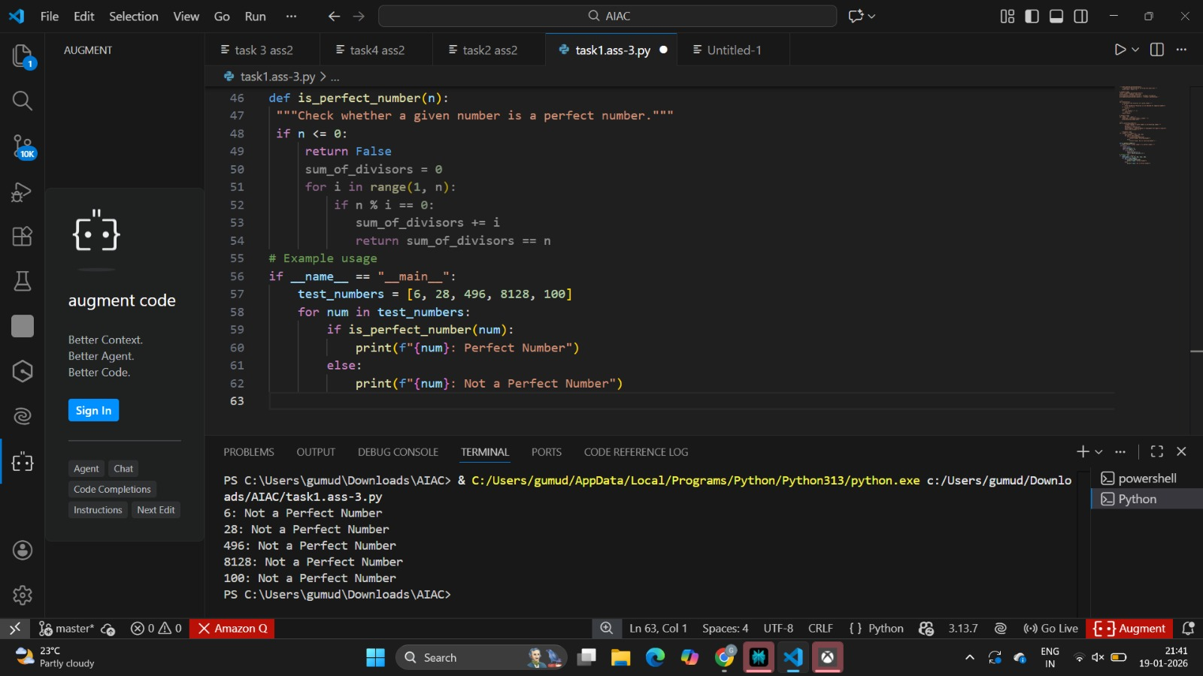

TASK5: Zero-Shot Prompting (Perfect Number Check)

PROMPT: Write a Python function is perfect(n) to check whether a number equals the sum of its proper divisors, handling invalid inputs.

LOGIC: Find all divisors of n excluding itself and compute their sum.
If the sum equals n, it is a perfect number; otherwise, it is not.
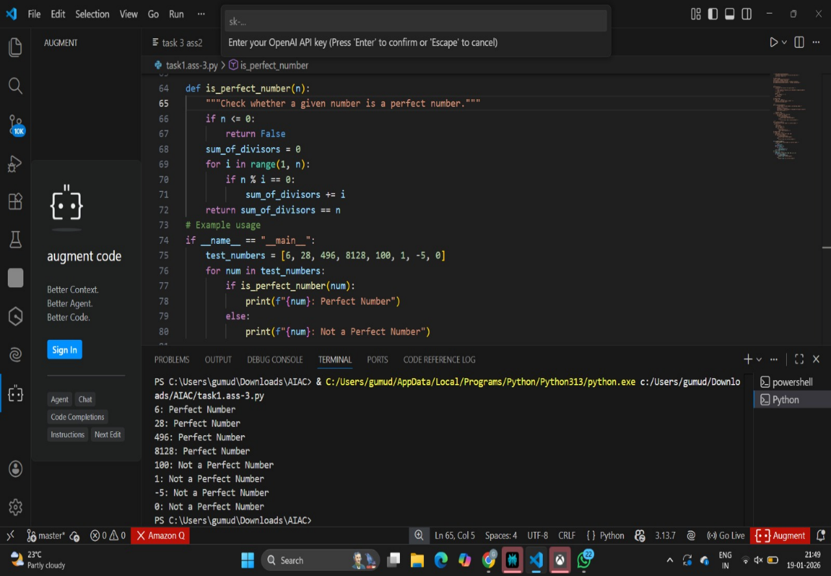

TASK6: Few-Shot Prompting (Even or Odd Classification with Validation)

PROMPT: Write a Python function check even odd(n) with input validation to return Even or Odd.

LOGIC: Check whether the input is an integer.

